

INDIVIDUAL ASSIGNMENT
TECHNOLOGY PARK MALAYSIA
CT050-3-3-RTS
REAL TIME SYSTEM
(SENSOR DATA SPECIALIST)

NAME | : | SAMANTHA KOK JIA YIN
TP NUMBER | : | TP066133
NAME OF LECTURER | : | ASSOC. PROF. DR. IMRAN MEDI
SUBMITTED ON | : | 25th May 2025
GROUP NUMBER | : | 22

Table of Contents
Table of Contents 2
List of Figures 3
List of Tables 4
1.0 Abstract 5
2.0 Introduction 5
2.1 Problem Statement 6
2.2 Aim 6
3.0 Literature Review/ Related Work 7
3.1 Performance against other programming languages 7
3.2 Memory safety in Rust 8
3.3 Asynchronous programming in Rust 9
4.0 Sensor Data Specialist 10
4.1 Design 10
4.2 Cup’s Nature 14
4.3 Communication 15
4.4 Dependencies 16
4.5 Main Function 17
4.6 Sensor Data Utility Function 19
4.7 Components Flow 21
4.7.1 Cup Allocation – Sensor 1 21
4.7.2 Midpoint of the conveyor belt – Sensor 2 23
4.7.3 Grip – Sensor 3 23
4.7.4 Robot Claw – Sensor 4 24
4.7.5 Robot Arm – Sensor 5 25
4.7.6 Window Allocation – Sensor 6 26
4.8 Output 27
4.9 Benchmarking 29
4.9.1 Generate cup fullness 29
4.9.2 Moving average 30
4.9.3 Simulation of ETA 31
5.0 Conclusion 32
References 33

List of Figures
Figure 1: Performance Metrics of programming language (Stack Overflow Developer , 2024) 7
Figure 2: Cup Structure 14
Figure 3: Sensor Message 15
Figure 4: Dependencies for controller 16
Figure 5: Initialization Phase in Main Function 17
Figure 6: Main Function 17
Figure 7:Main Function 18
Figure 8:Main Function 18
Figure 9: Utility Functions 19
Figure 10: UDP Transmission and Cup Travel Simulation Functions 19
Figure 11: Cup Allocation - Sensor 1 21
Figure 12: Cup Allocation - Sensor 1 22
Figure 13: Cup Allocation - Sensor 1 22
Figure 14: Midpoint - Sensor 2 23
Figure 15: Grip - Sensor 3 23
Figure 16: Robot Claw - Sensor 4 24
Figure 17: Robot Arm - Sensor 5 25
Figure 18: Window Allocation - Sensor 6 26
Figure 19: Window Allocation - Sensor 6 26
Figure 20: Sample output when it detects low weight anomaly 27
Figure 21: Sample output when the cup is full 27
Figure 22: Sample output when the cup is full 28
Figure 23: Sample output of high temperature anomaly and temperature emergency 28
Figure 24: Sample output for final Statistic 28
Figure 25: Distribution Plot for cup fullness 29
Figure 26: Line plot for cup fullness 29
Figure 27: Distribution plot for moving average 30
Figure 28: Line plot for moving average 30
Figure 29: Distribution plot for ETA 31
Figure 30: Line plot for ETA 31

List of Tables
Table 1: Functionality of each sensor 14
Table 2: Cup's structure characteristic 15
Table 3: Sensor communication description 16
Table 4: Dependency description 17

Abstract
This project focuses on developing a real-time robotic cup-handling simulation system using Rust. The core objective is to implement a sensor-side module (Student A) capable of generating, processing, and transmitting sensor data. This includes data like temperature, weight, and position within a strict 5ms cycle. Rust was chosen for its strong memory safety, zero-cost abstractions, and asynchronous capabilities. Additionally, the system uses UDP for communication with the actuator module and features real-time anomaly detection and movement simulation. Benchmarking was shown to prove that the system components meet the timing expectations with minimal variance, demonstrating Rust’s suitability for responsive, reliable, and safe real-time applications.

Introduction
Real-time systems are computing environments where the correctness of operations depends not only on the logical results but also on the precise timing of those results. According to Maggio and Erikårzén (2020), they indicate that in real time system, tasks must be completed within the strict time constraints to avoid failure or unsafe behaviour. Real-time systems are essential in domains such as robotics, medical devices, aerospace, and automated manufacturing. This is because if the system was delayed even by few milliseconds, it may cause significant errors, system damage, or serious accidents (IBM, 2025). These systems demand high predictability, consistent timing, and low-latency performance and thus makes the underlying software and hardware architecture critically important. To meet these demands, this project utilizes Rust, a modern systems programming language known for its emphasis on memory safety, high performance, and fearless concurrency without relying on a garbage collector (Dahiya & Dharani, 2023). Additionally, Rust’s unique ownership model and compile-time able to help in eliminating the common low-level bugs such as memory leaks, race conditions, and null pointer dereferencing (Joshi, 2025). These features make it exceptionally well-suited for developing real-time and safety-critical applications (Make Computer Science Great Again, 2024). Thus, in this project, we are focuses on implementing a real-time robotic actuator module using Rust to handle sensor inputs like force, weight, and temperature with precise timing. The goal of this project to simulate intelligent robotic behaviour while ensuring reliable and deterministic control for cup-handling operations under strict real-time constraints.

Problem Statement
In modern manufacturing and logistics industry, automation systems often rely on robotic arms to handle fragile items such as cups or containers (AIIEM, 2025). However, many of these systems face significant challenges related to timing precision, control accuracy, and anomaly responsiveness. Delayed actuation, unfiltered sensor noise, and insufficient real-time feedback mechanisms can lead to operational failures such as item breakage, misplacement, overheating of actuators, or inefficient retries (Benedicte et al., 2019). These issues are further exacerbated when systems operate under soft or hard real-time constraints, where every millisecond matters (Wallace, 2023). Traditional programming environments often lack the tools necessary to guarantee memory safety and concurrency without sacrificing speed and this will lead to unpredictable behavior or unsafe operations (Goudarzi, 2023). There is a growing need for a real-time control system that is both robust and predictable especially for applications that require high-frequency updates and deterministic outcomes in the presence of physical feedback.

Aim
Thus, the aim of this project is to design and implement the sensor-side module of a real-time robotic cup-handling system using the Rust programming language. The primary focus of this system is on Student A’ role which is the sensor specialist. The system simulates a continuous flow of the cups through a series of 6 virtual sensors. Each sensor responsible for different stages of the process, starting from cup allocation and temperature/weight measurement, up to final placement at the window. The sensor module is designed to operate under a strict 5-millisecond cycle, where sensor data generation, filtering, anomaly detection, and communication must complete in real time to ensure reliable downstream actuation. Moreover, this sensor-side system captures and processes various physical attributes such as cup ID, weight, temperature, position, and belt speed. It applies to a moving average filter for temperature smoothing and uses rule-based logic to detect anomalies like low weight or overheating. Identified issues and sensor status updates are transmitted to the actuator module using User Datagram Protocol (UDP) within a 1-millisecond deadline. The sensor logic also simulates intelligent decision-making, such as skipping underfilled cups, coordinating with actuator feedback, and retrying placement if the target window is occupied. By leveraging Rust’s concurrency model, low-level control, and asynchronous I/O capabilities, this project demonstrates how a safe, fast, and deterministic sensor system can be developed to support real-time robotic operations in automated environments.

Literature Review/ Related Work
Real time robotic systems require precise synchronization, safe memory operations, and high-speed data processing, particularly on the sensor side, where latency and determinism are crucial. This section outlines the comparative advantages of Rust for real-time applications, with a focus on performance, memory safety, and asynchronous programming, contextualized with prior research and projects.

Performance against other programming languages
When it comes to building systems that are fast, reliable, and safe especially in real-time systems, choosing the right programming language can significantly make a huge difference. Among many options available today, Rust has stood out as one of the most loved and trusted languages. According to the 2024 Stack Overflow Developer Survey, an impressive 86.98% of developers said they enjoy using Rust and would use it again, putting it well ahead of languages like Clojure, TypeScript, and Python. This isn't just about popularity but it's a reflection of how effective and satisfying Rust is to work with.
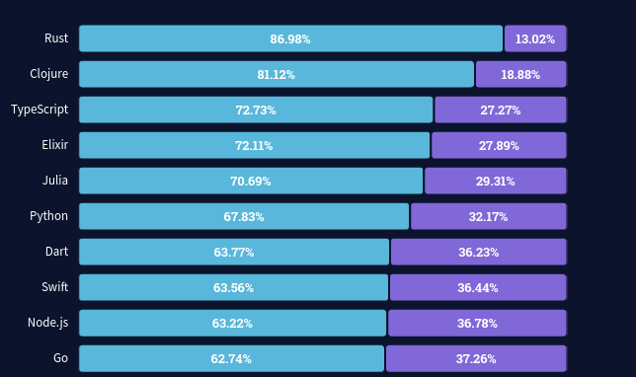
Figure 1: Performance Metrics of programming language (Stack Overflow Developer , 2024)
One of the most advantages of Rust is that it does not rely on the garbage collector. Languages like Java or Python use garbage collectors. This will pause the program periodically to reclaim memory, introducing unpredictable delays. However, Rust uses ownership-based memory management that enables memory automatically when values go out of scope. This are all handled at compile time to ensure memory safety(Sling Academic, 2025). By that it can lower the runtime overhead and more consistent performance, especially under heavy load or time-critical tasks.
In addition, Rust supports zero-cost abstractions, which means developers can write clean, high-level code without sacrificing performance. However, constructs like iterators, closures, and pattern matching compile down to efficient machine code which often equivalent to hand-optimized C implementations (Czepliewicz, 2025). Moving on, in the context of this cup-handling simulation, these abstractions play a crucial role. For example, sensor data such as temperature, weight, and position must be processed within strict timing limits which are 2ms processing and 1ms transmission. Thus, by using Rust’s, it can ensure that these tasks are completed with minimal overhead, even as multiple sensor stages are executed concurrently.

Memory safety in Rust
Secondly, are the powerful features of rust which is memory safety. It enforced entirely at compile time. Traditional languages like C and C++ offer high performance but place the burden of memory management entirely on the developer. This can lead to critical issues such as memory leaks, buffer overflows, dangling pointers, and use-after-free errors (Baghai, 2024). However, in contrast, Rust provides a modern solution by enforcing memory safety at compile time through its ownership and borrowing model (Dhawan, 2024). This model ensures that every value in a Rust program has a clear owner, and the memory is automatically deallocated when that owner goes out of scope (Rustcode, 2025)
Moving on, Rust’s memory model operates on strict but intuitive rules. For example, each value can only have one owner at a time, and either one mutable reference or multiple immutable references may exist. Once a variable’s ownership is transferred to another, the original variable can no longer access the value, Thus, by that it able to prevents issues that is related to multiple references modifying the same memory space. These constraints are enforced by the Rust compiler which helps the developers to identify and resolve the memory-related errors during compilation rather than at runtime (Wofford, 2024). This approach not only promotes safer code but also contributes to system stability especially in real-time environments where unexpected failures are unacceptable.
In this project, memory safety plays a vital role in the reliable operation of the robotic cup-handling system. Since the system is responsible for continuously reading, processing, and transmitting sensor data such as temperature, weight, and position, any memory-related issue could compromise the accuracy of the entire operation. For example, the use-after-free or data race conditions during concurrent sensor updates could lead to false anomaly detection or delayed responses to overheating events. Rust eliminates such risks by default and thus allows the system to maintain correct behaviour across all sensor stages even when executed concurrently or asynchronously.

Asynchronous programming in Rust
Asynchronous programming has become a fundamental approach in the development of real-time systems which enable multiple operations to execute concurrently without blocking each other. In Rust, asynchronous functionality is primarily built around the Future trait and implemented using the async and await syntax (Leapcell, 2025). Rather than occupying the system resources while waiting for I/O or timed tasks to complete, Rust's async model allows programs to yield control and resume tasks only when they are ready. Studies by Arash Sal Moslehian (2023) have shown that asynchronous programs consume less CPU and memory while achieving faster performance compared to their synchronous counterparts. This efficiency is particularly important in real-time applications where time-sensitive operations must occur in parallel, such as sensor readings, data processing, and communication with other modules (Turing, 2025).

In this project, asynchronous programming plays a critical role in managing the real-time flow of cup data across multiple sensor stages. Each cup requires consistent monitoring, anomaly detection, and transmission of status updates to the actuator within strict timing windows (≤5ms per cycle). By leveraging the Tokio runtime, which uses a scalable, work-stealing scheduler, the sensor module is able to concurrently process data like listen for feedback and transmit results via UDP without performance degradation. Moreover, Rust’s async model not only enables these concurrent tasks to run smoothly but also ensures thread safety through strong type guarantees and memory safety mechanisms. This makes asynchronous programming in Rust not just an optimization but also a foundational enabler of the responsiveness and reliability that required by the real-time robotic cup-handling system.

Sensor Data Specialist

Design
The robotic cup handling system is designed to work like a well-coordinated team, where each of the six sensors has its own job and depends on the one before it. The process starts when a cup enters the system. Sensor 1 will take the lead by giving the cup a unique ID, checking for the fullness of the content inside the cup, measuring the weight and temperature. By capturing all these data, the system able to check if the cup is full and is ready to proceed. If the cup is ready to go, it will process to the next sensor which is sensor 2.

As the cup reaches Sensor 2, it will check if the cup is moving properly by confirming if it has reached the halfway point. It will keep track of the cup’s status, timing, and position and once it reaches the end of the conveyor, Sensor 3 will take action. Sensor 3 will step in to verify that the cup is in the right spot to be picked up. This is to make sure that the cup is ready for the robotic arm to take over.

At that moment, Sensor 4 stimulates the robotic claw to grab the cup and ready to be transferred. After the grip, Sensor 5 tells the robotic arm to rotate and move the cup to the placement area of the window, if something goes wrong, back to try again. Finally, is Sensor 6, where it checks if the window is available. If it’s free, the cup is placed, if not, the system waits and retries. Throughout this process, each sensor captures detailed data to make sure everything is running smoothly, safely and efficiently.

Anomaly detection
In this real-time system, there are 2 specific types of anomalies that will be monitored which is the low weight of the cup and the high temperature. If a cup weighs less than 485.0g, it is flagged as a low-weight anomaly, indicating that the cup may be underfilled or defective. Additionally, if the cup’s temperature exceeds 50°C, it is considered a high-temperature anomaly. By detecting these two anomalies, the system can identify cups that may be faulty or pose a potential risk, allowing it to take appropriate action before allowing the cups to proceed further down the processing line.

Emergency detection
However, this system also contains three emergency detection mechanisms. The first emergency scenario is triggered at Sensor 1 if a cup’s temperature exceeds 50°C. In this case, the system sends a signal to Student B indicating that the cup is too hot, prompting a cooling response before the cup can proceed further. This scenario simulates a real-world safety precaution.

The second emergency detection concerns the cup’s fullness. Each cup is assessed as either Empty, Not Full, or Full. If a cup is found to be Empty or Not Full, it is automatically skipped, and a notice is displayed indicating that the cup needs to be refilled. This mimics a quality control check, ensuring that only properly filled cups are processed.

The third emergency occurs at the final stage, which is Sensor 6, responsible for monitoring the placement window. If the window is already occupied when a cup arrives, the system reduces the conveyor belt speed from 100 m/s to 50 m/s to prevent any collision or congestion. A message is displayed to inform that the window is currently unavailable, and the system takes appropriate action by reducing the speed or retrying the placement once the window becomes free. These emergency responses ensure that the system behaves intelligently and safely, which is a key objective of a real-time system.

Below is the table indicating each functionality for each sensor.
Sensor | Purpose | Location | Trigger | Data captured
Sensor 1 – Cup Allocation | Initiates cup processing by assigning ID, measuring weight and temperature | Start of the Accumulator | Cup is placed into the system | - Cup ID  - Initial position (0.0 m)  - Weight (based on fullness status)  - Raw temperature  - Filtered temperature (moving average)  - Fullness status (Full / Not Full / Empty)  - Temperature category (Cold / Normal / Hot)  - Start timestamp
Sensor 2 – Midpoint Sensor | Confirms cup has reached midpoint of the belt | Middle of the Accumulator | Cup passes halfway line | - Cup ID  - Fullness status  - Temperature category  - Travel time to midpoint (actual vs ETA)  - Cup position  - Elapsed time since allocation
Sensor 3 – Grip Detection | Verifies cup has reached the grip zone and is ready for pickup | End of the Accumulator (Grip Zone) | Cup reaches grip point | - Cup ID  - Readiness status (implied by arrival)  - Weight  - Temperature  - Travel time to grip zone (actual vs ETA)  - Elapsed time since allocation
Sensor 4 – Robot Claw | Simulates robotic claw action to grip the cup | Claw Area (before rotation) | Cup is gripped by claw | - Cup ID  - Pickup request timestamp  - Readiness status (request to pick up with claw)  - Elapsed time since allocation
Sensor 5 – Arm Grip Action | Simulates rotation of robotic arm to window or retry | Arm Pivot Zone | Claw action triggered rotation | - Cup ID  - Rotation direction (to Window / Accumulator)  - Retry flag (false for first attempt, true if retrying)  - Travel time to pivot  - Elapsed time since allocation
Sensor 6 – Window placement | Verifies if placement zone (window) is free or occupied | Window Area | Cup reaches the placement point | - Cup ID  - Window availability (free / occupied)  - Placement success or retry  - Travel time to window  - Elapsed time since allocation  - Belt speed adjustment log (restore if free)
Table 1: Functionality of each sensor

Cup’s Nature

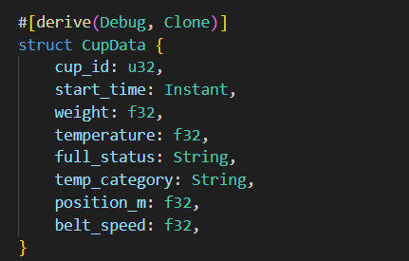
Figure 2: Cup Structure
Cup’s Characteristic | Description
cup_id | A unique id given to each up in order to keep track of it individually.
start_time | The exact moment of the cup entered the system. This helps us to measure how long the cup takes to go through the entire process.
weight | How heavy is the cup. Heavier cups usually mean that they are full while lighter cups indicate that they are not full or are empty.
temperature | The temperature of the cup, whether it is hot or cold. This is important in order to detect any overheating that could harm the robotic arm.
full_status | A simple label of the cup’s whether is ‘Full’, ‘Empty’ or ‘Not Full’. If the cup is empty or not full, the system will send the message to student B to refill it.
temp_category | A quick way to see whether the temperature is ‘Cold’, ‘Normal’, ‘Hot”. It is based on its actual temperate value.
position_m | Where the cup is currently located on the conveyor belt in meters. This helps to stimulate its movement through the system.
belt_speed | How fast is the conveyor belt moving when handling the cup. The speed will reduce by 50m/s if the system detects that there is still a cup at sensor 6.
Table 2: Cup's structure characteristic

Communication
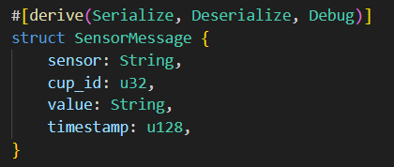
Figure 3: Sensor Message
Characteristic | Description
sensor | The name of the sensor sending the message for example "Sensor1" or "Sensor4".
cup_id | The ID of the cup this message is about. It tells the receiver which cup the message refers to.
value | The actual content of the message. For example: "Weight: 502.5g" or "Action: Grip Cup". It can also report problems like "Refill Request" or "Anomaly Detected".
timestamp | The exact time the message was generated, measured in milliseconds since the UNIX epoch. This is used to calculate message delays, measure system latency, and preserve the correct sequence of sensor events.
Table 3: Sensor communication description

Dependencies
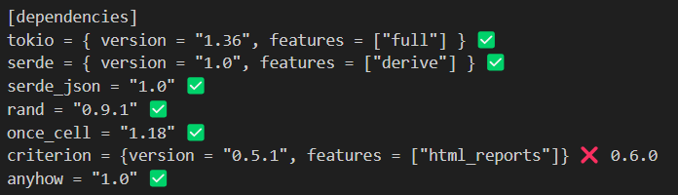
Figure 4: Dependencies for controller
Dependency | Description
tokio | Enables asynchronous operations like timers (sleep, interval) and non-blocking networking (UdpSocket). It’s the engine that makes the real-time simulation run smoothly.
serde | Convert Rust data (like struct) into formats like JSON, and vice versa.
serde_json | Works together with serde to specifically handle JSON data for instance: encoding and decoding it as strings during communication.
rand | Generate random numbers which are used in stimulating the random weights, temperature and the cup statuses like ‘full’ or ‘empty’
one_cell | Able to create global static values like emergency flags that are only initialized once and can be safely accessed from anywhere.
criterion | It is a benchmarking tool to measure how fast parts of the code run. It gives you detailed performance reports, including HTML charts.
anyhow | It is a crate for simplified error handling. It allows returning a single error type with helpful messages and thus, make it easier to handle and propagate errors cleanly in async and real-time code.
Table 4: Dependency description

Main Function
The main function controls the entire robotic sensor simulation. It sets up shared resources like the UDP socket, window state, and performance counters, then runs a loop every 5ms to simulate real-time cup processing. Each cycle creates a cup, filters out invalid ones, and sends valid cups through virtual sensors. It adjusts belt speed based on window availability, logs sensor activity, and tracks performance at 25s and 45s. After 60 seconds, it prints a final summary of the system’s performance. The figures below display the code for this main loop.
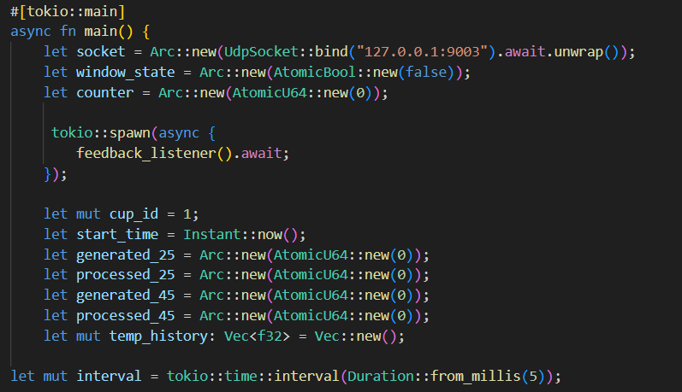
Figure 5: Initialization Phase in Main Function
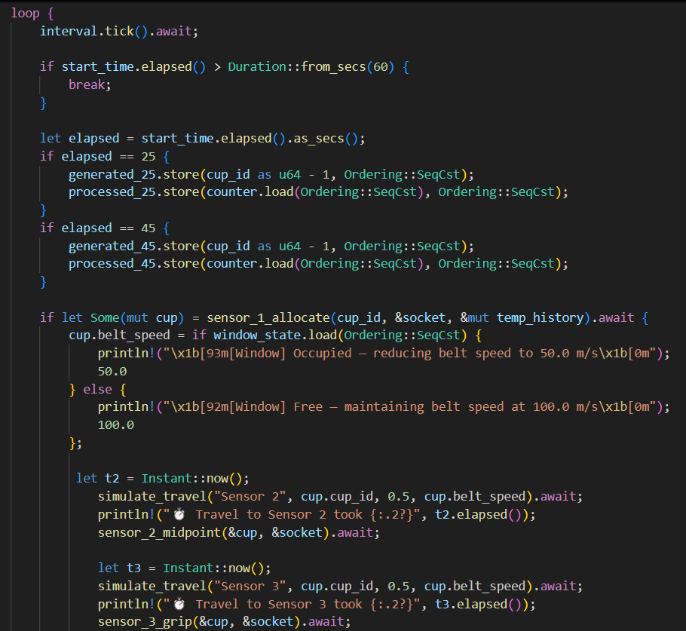
Figure 6: Main Function
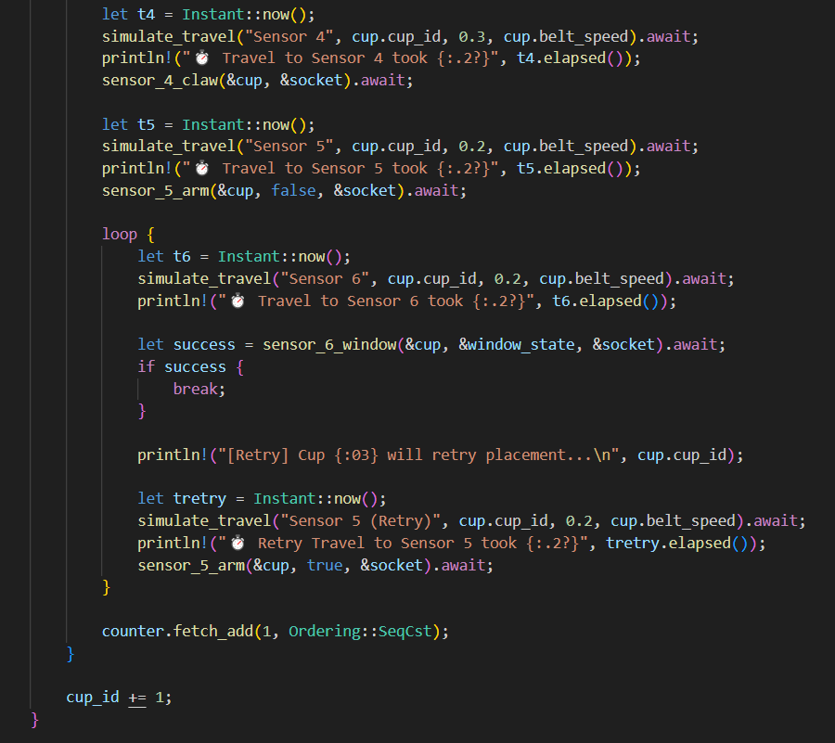
Figure 7:Main Function
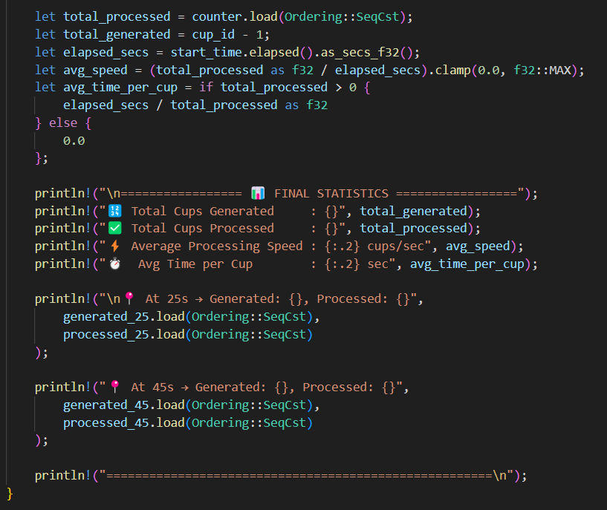
Figure 8:Main Function

Sensor Data Utility Function
These utility functions support the simulation by classifying sensor data, detecting irregularities, and smoothing noisy values. They play a critical role in emulating realistic sensor behavior in a real-time robotic control system.
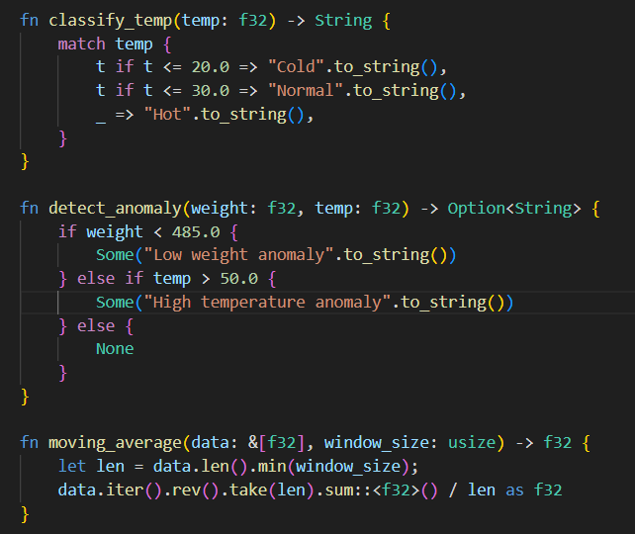
Figure 9: Utility Functions
These 3 utility functions improve the realism and accuracy of the simulated sensor system. The “classify_temp” function converts raw temperature readings into human-readable labels such as "Cold", "Normal", or "Hot". The “detect_anomaly” function flags abnormal cups based on weight and temperature thresholds. Lastly, the “moving_average" function smooths recent temperature values to reduce noise.
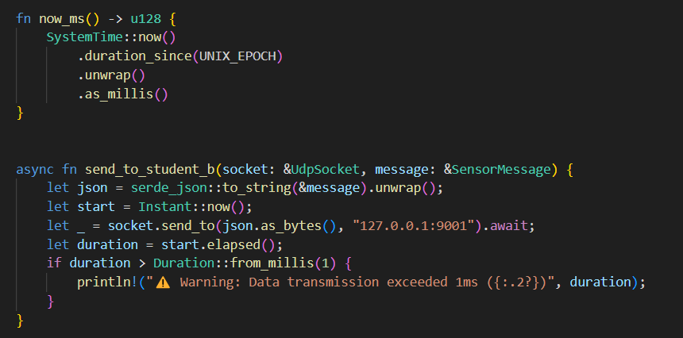
Figure 10: UDP Transmission and Cup Travel Simulation Functions
The “now_ms” function returns the current system time in milliseconds since the UNIX epoch. It is used to timestamp sensor messages for tracking latency and event order in the system. However, the “send_to_student_b” function sends sensor data from Student A to Student B via UDP by converting a ‘SensorMessage’ into JSON and transmitting it to a fixed address. It also measures the transmission time and logs a warning if it exceeds 1 millisecond to ensure real-time performance.
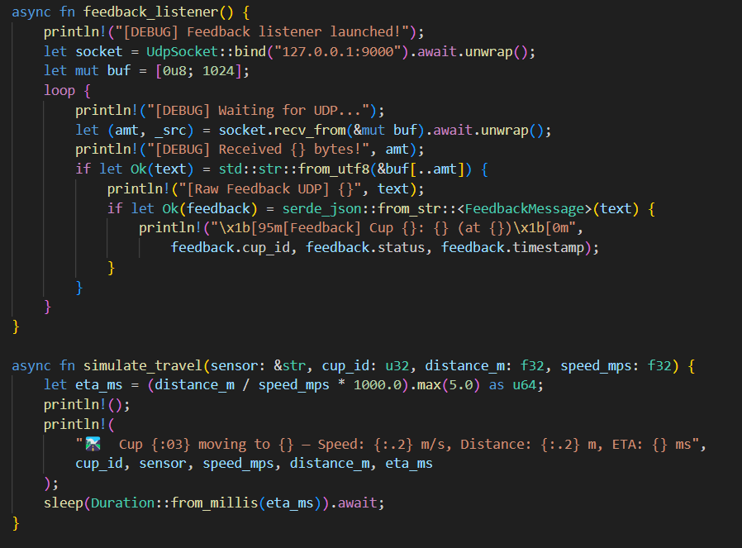

The “feedback_listener” function continuously listens for incoming UDP messages from the actuator module (Student B). It binds to a local address and decodes the received JSON feedback into a FeedbackMessage. It will print the cup ID, status, and timestamp which can help in verifying that communication success and maintain synchronization between sensors and actuators. Meanwhile, the “simulate_travel” function mimics the cup's physical movement by calculating its ETA based on distance and speed, with a minimum delay of 5ms. It logs the cup’s movement details and uses “sleep” to simulate transit time, adding realism and timing accuracy to the simulation.

Components Flow

Cup Allocation – Sensor 1

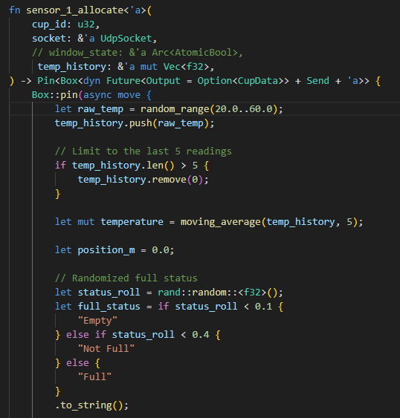
Figure 11: Cup Allocation - Sensor 1
It will randomly generate the temperature between 10°C and 60°C. It is assigned to simulate environmental conditions. After that, the value will be pushed into a history buffer (temp_history) to support smoothing. However, the most recent 5 temperature values are averaged to reduce the impact of random spikes. This improves accuracy in anomaly detection and classification. Additionally, the cup will be located at the position of 0.0m which is the starting point of the system. It will then randomly choose the full status of the cup.
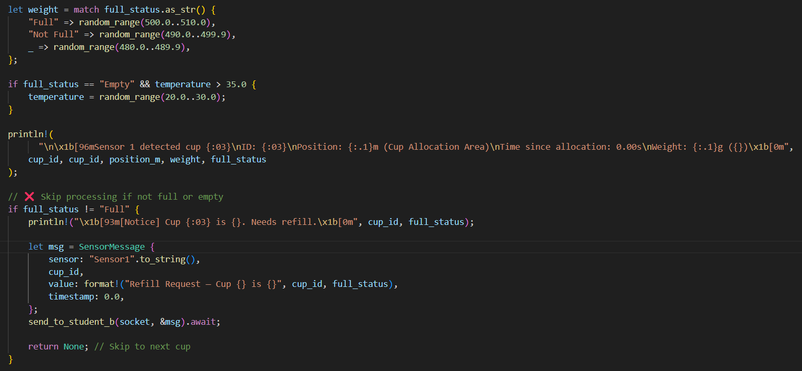
Figure 12: Cup Allocation - Sensor 1
Moving on, the system will also assign weight based on its full status. "Full" cups are heavier (500–510g), "Not Full" cups are medium weight (490–499.9g) and “Empty" cups are light (480–489.9g). However, if the cup is empty and too hot (>35°C), the temperature is adjusted to avoid false overheating detection. Additionally, if the cup is not "Full", it is rejected, and a "Refill Request" is sent to Student B via UDP, simulating a feedback loop to alert the actuator.
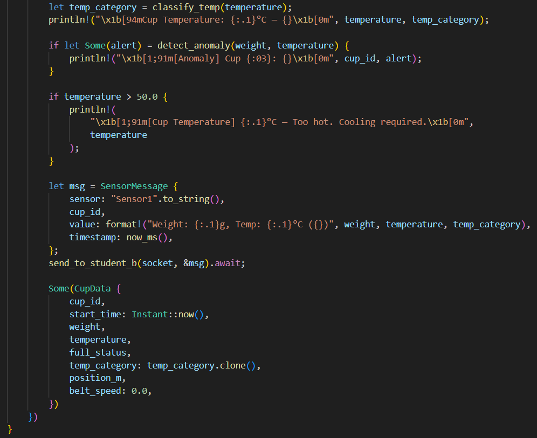
Figure 13: Cup Allocation - Sensor 1
The “detect_anomaly” function plays a key role in identifying irregular cup conditions. If a cup is underweight (less than 485g) or overheated (above 50°C), a red warning is printed to alert the operator, showing either “Low weight anomaly” or “High temperature anomaly” depending on the case. Despite these anomalies, as long as the cup is labeled as "Full", it is still allowed to continue through the system. Its complete profile including weight, temperature, status, and temperature category is wrapped in a SensorMessage and sent to Student B for further action.

Midpoint of the conveyor belt – Sensor 2
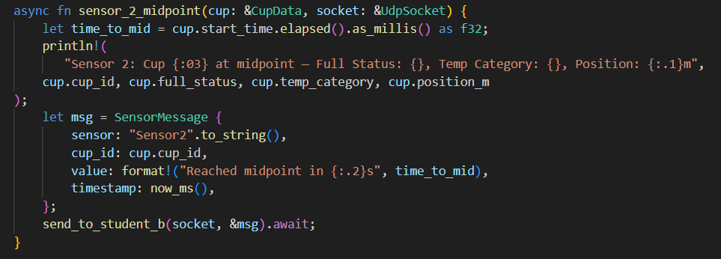
Figure 14: Midpoint - Sensor 2
The sensor_2_midpoint function acts as a midway checkpoint in the cup’s journey. It calculates how much time has passed since the cup was first detected and logs essential info like the cup ID, fill level, and temperature category. This helps track how quickly the cup moves through the system. It then sends a structured message to Student B to stay updated on the cup's real-time location and status.

Grip – Sensor 3
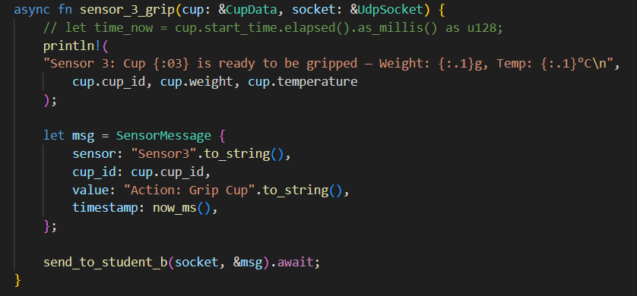
Figure 15: Grip - Sensor 3
The sensor_3_grip function represents the stage where the robotic arm prepares to grip the cup. It calculates the time taken since the cup was first detected and logs key details like the cup ID, weight, and temperature. This information is then sent to Student B to help align its gripping action precisely with the cup’s arrival in order to ensure real-time coordination.

Robot Claw – Sensor 4
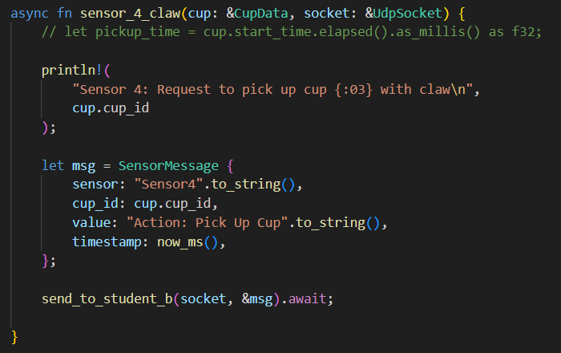
Figure 16: Robot Claw - Sensor 4
The sensor_4_claw function represents the stage where the robotic claw is requested to pick up the cup. It begins by calculating the time elapsed since the cup was first detected. A log message is printed to indicate that Sensor 4 is requesting to pick up the cup using the claw mechanism. This is followed by a sensor message which need to send to Student B to allow the actuator to initiate the claw action in sync with the simulation timeline.

Robot Arm – Sensor 5
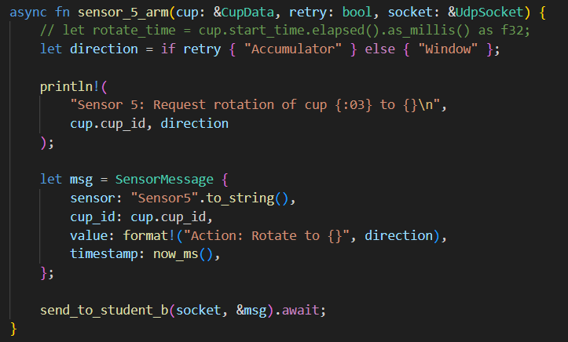
Figure 17: Robot Arm - Sensor 5
The sensor_5_arm function manages the rotation of the robotic arm based on whether the cup is making a first attempt or a retry. It calculates the time since the cup was first processed and decides the rotation direction like toward the "Window" or the "Accumulator". A corresponding “SensorMessage” is then sent to Student B to performs the correct movement based on real-time system conditions.

Window Allocation – Sensor 6
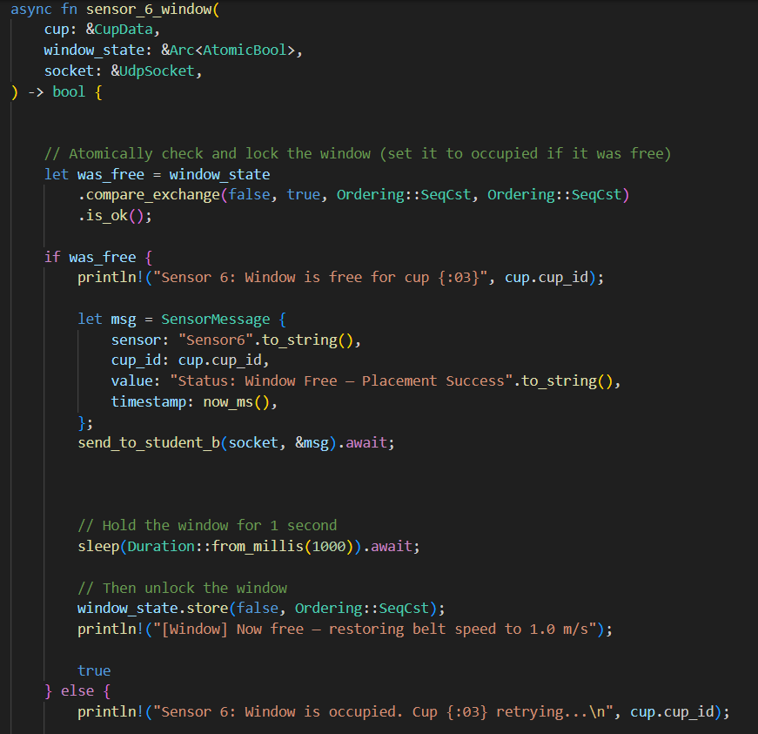
Figure 18: Window Allocation - Sensor 6
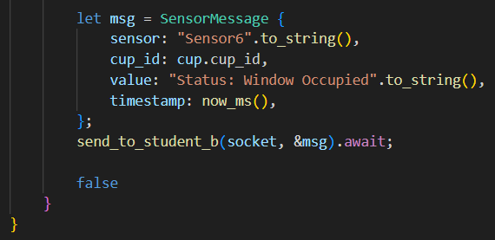
Figure 19: Window Allocation - Sensor 6
The sensor_6_window function checks if the placement window is free and manages access to it. If available, it locks the window, logs the success, sends a "Placement Success" message to Student B, and holds the window for 1 second before releasing it. If the window is occupied, it logs a retry message and sends a "Window Occupied" update instead. This ensures only one cup is placed at a time and provides real-time feedback to the actuator system.

Output
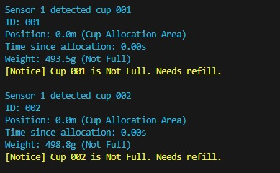
Figure 20: Sample output when it detects low weight anomaly
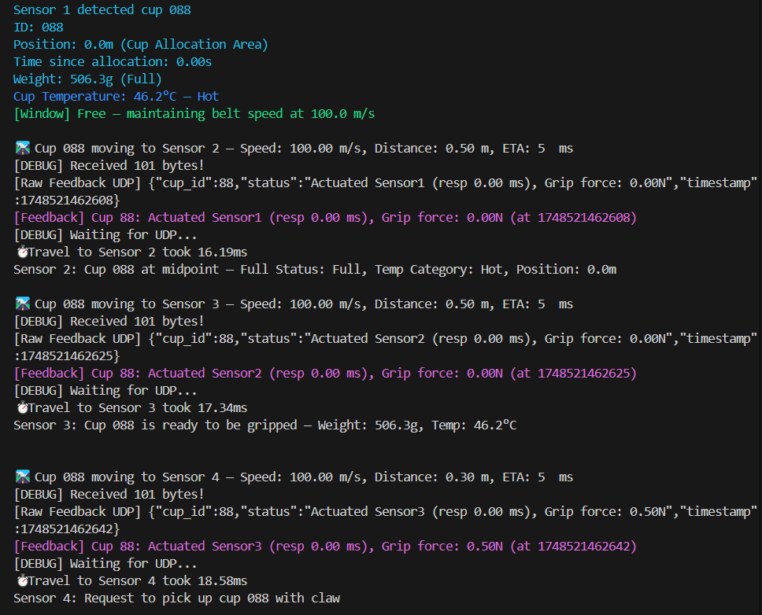
Figure 21: Sample output when the cup is full
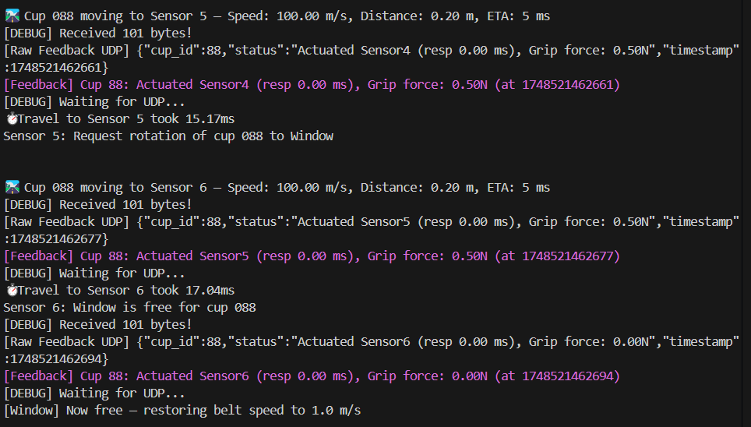
Figure 22: Sample output when the cup is full
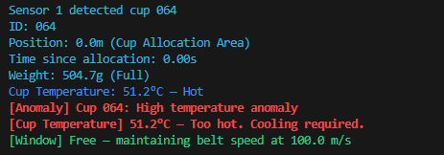
Figure 23: Sample output of high temperature anomaly and temperature emergency
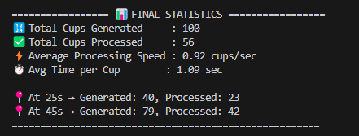

Figure 24: Sample output for final Statistic
The belt emergency notice was not shown because the window was always detected as free as the cups reached Sensor 6 more than 1 second apart and thus it allows the window to reset before the next cup arrived.

Benchmarking

Generate cup fullness
The benchmark results for generate_cup_full show that the function performs very quickly and consistently, averaging around 41.5 nanoseconds per call.
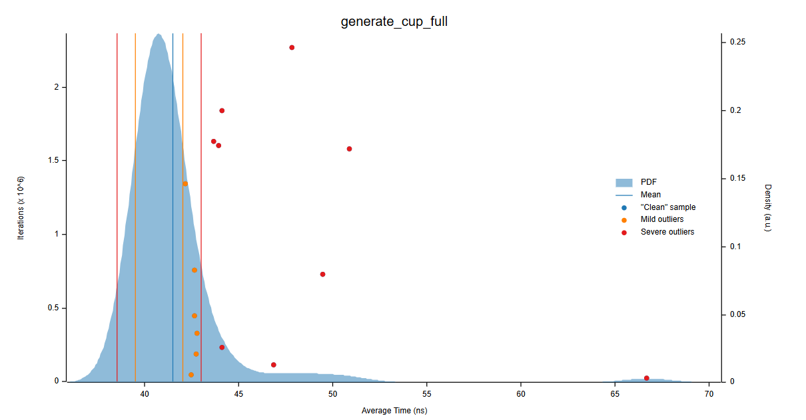
Figure 25: Distribution Plot for cup fullness
The distribution graph confirms that most samples are tightly packed around this value, with only a few outliers appearing slightly later than expected. This indicates that it has stable performance with rare spikes.

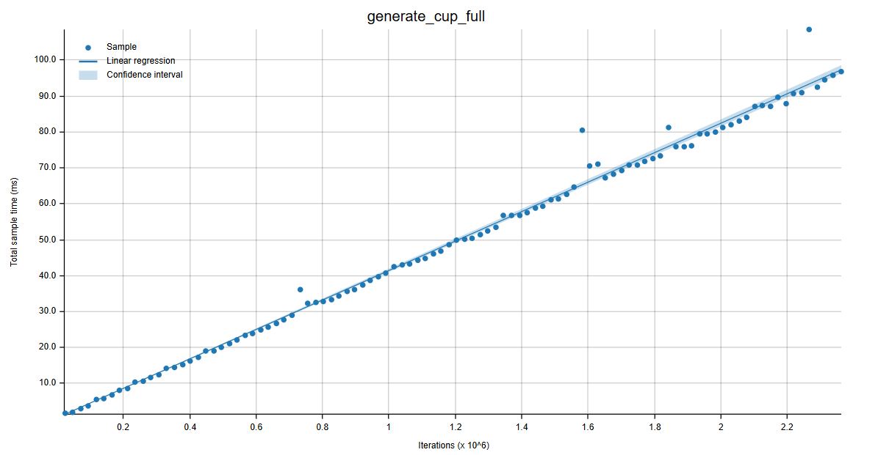
Figure 26: Line plot for cup fullness
However, the linearity graph shows that execution time scales predictably over many iterations which are great for real-time systems.

Moving average
The moving_average_5 benchmark measures how efficiently the system calculates a moving average over a small window of five values. This benchmark is crucial as it helps in filtering the noisy sensor data.
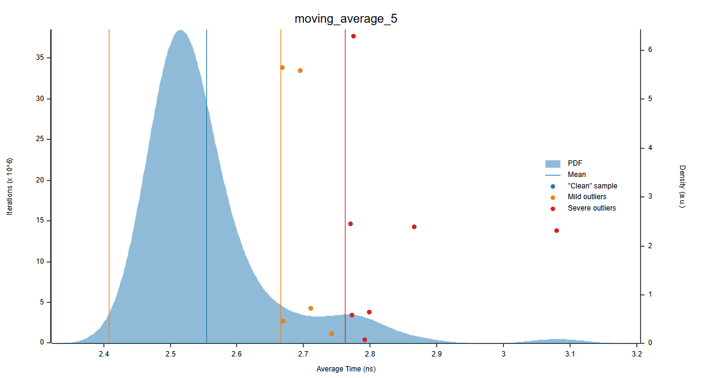
Figure 27: Distribution plot for moving average
The first graph shows that most executions are tightly clustered around 2.5 to 2.6 nanoseconds, with a few mild and severe outliers. This indicates generally stable performance with occasional delays, possibly from cache misses or system interruptions.

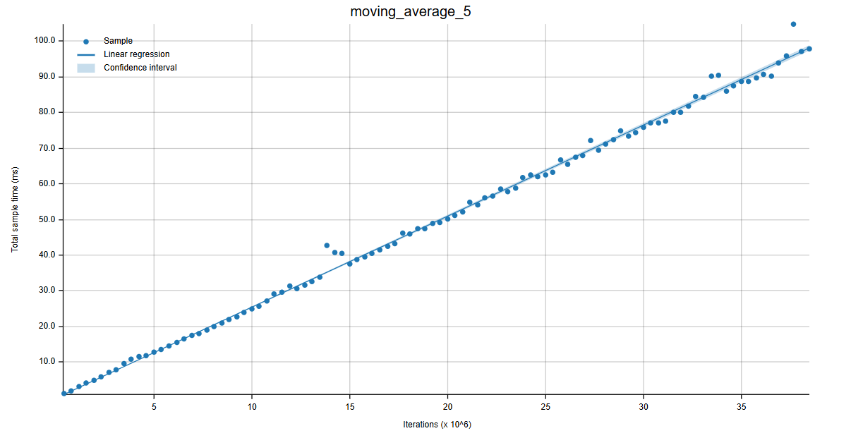
Figure 28: Line plot for moving average
However, the second graph shows a strong linear pattern in execution time across millions of iterations. This shows that the function scales well and behaves predictably under load. These results confirm that the moving average function is fast, consistent, and suitable for real-time filtering in your cup-handling system where precise and quick sensor smoothing is essential.

Simulation of ETA
The benchmark for simulate_eta_0.5m_100mps evaluates how quickly the system can calculate estimated travel time for a cup moving 0.5 meters at 100 m/s.
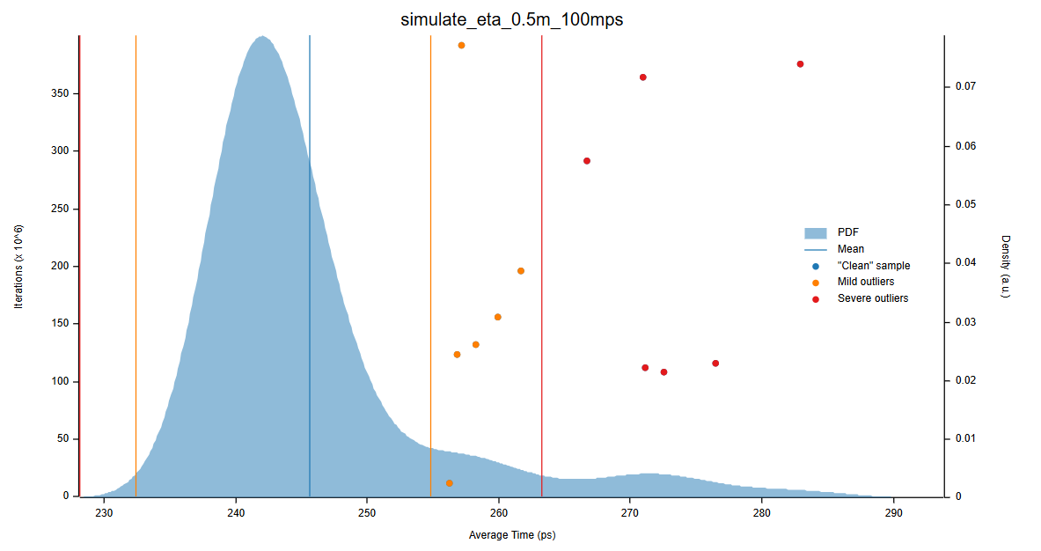
Figure 29: Distribution plot for ETA
The distribution graph shows that most samples are tightly clustered around 240–250 picoseconds means that it is fast and stable execution. However, there are several mild and severe outliers beyond 260ps likely caused by background system processes or cache effects.
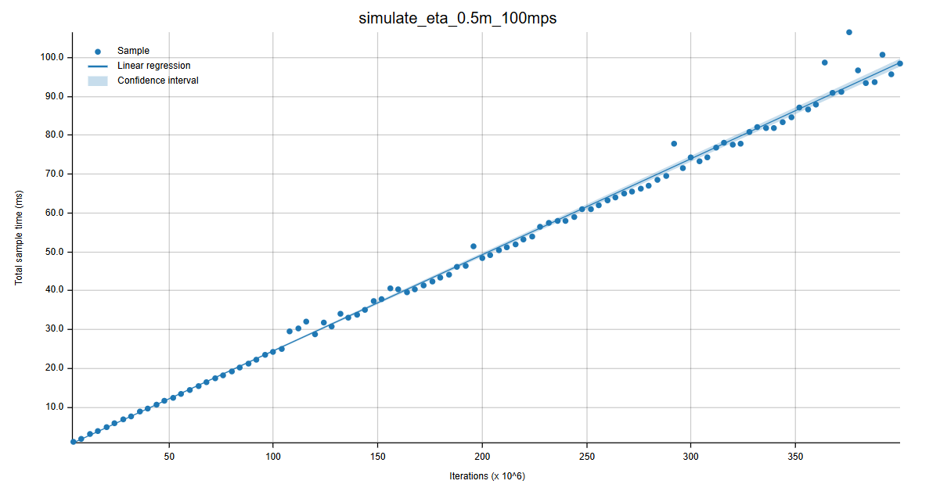
Figure 30: Line plot for ETA
Additionally, the linear regression plot shows that execution time scales predictably across many iterations which is critical for real-time simulation accuracy. Overall, this function demonstrates excellent speed and consistency making it suitable for high-frequency movement simulations in your robotic system.

Conclusion
This project successfully shows how a real-time sensor system can be built using the Rust programming language to handle robotic cup movement smoothly and efficiently. The system was able to simulate how cups move, detect issues like overheating or low weight, and send data quickly and reliably to the actuator. This is done by combining the asynchronous programming, safe memory handling, and fast UDP communication. Besides, the performance benchmarks showed that key functions like generating data, filtering it, and calculating movement ran consistently and fast. Thus, in conclusion, Rust proved to be a great choice for time-sensitive task by offering both speed and safety for building real-time systems that need to work without fail.

Word Count: 3715 (exclude headings, table of content, list of tables, list of figures, references, citation, and tables)

References
AIIEM. (2025, February 22). The Role of Robotics in Modern Manufacturing. Arab Institute of Industrial Engineering and Management. https://aiiem.org/the-role-of-robotics-in-modern-manufacturing/
Arash Sal Moslehian. (2023, January 25). An Introduction to Asynchronous Programming in Rust and a High-level Overview of Tokio’s Architecture. Arash Sal Moslehian. https://moslehian.com/posts/2023/1-intro-async-rust-tokio/
Baghai, C. (2024, January 20). Memory Management in Low-Level Languages: A Trade-Off Between Performance and Safety. Medium. https://christianbaghai.medium.com/memory-management-in-low-level-languages-a-trade-off-between-performance-and-safety-b4bf5d0caa12
Benedicte, P., Abella, J., Hernandez, C., Mezzetti, E., & Cazorla, F. J. (2019). Towards limiting the impact of timing anomalies in complex real-time processors. Proceedings of the 24th Asia and South Pacific Design Automation Conference, 27–32. https://doi.org/10.1145/3287624.3287655
Dahiya, K., & Dharani, A. (2023, July 5). Building High-Performance Rust Applications: A Focus on Memory Efficiency. Social Science Research Network. https://doi.org/10.2139/ssrn.4518760
Dhawan, S. (2024, September 28). Memory Safety in Rust: A Deep Dive - Shivanshi Dhawan - Medium. Medium. https://medium.com/@shivanshidhawan/memory-safety-in-rust-a-deep-dive-e0c7196caa67
Goudarzi, F. (2023). An Introduction to Memory Safety Concepts and Challenges. The AdaCore Blog. https://blog.adacore.com/an-introduction-to-memory-safety-concepts-and-challenges
IBM. (2025, March 26). Real-time operating system (RTOS). Ibm.com. https://www.ibm.com/think/topics/real-time-operating-system
Joshi, A. (2025, April 6). Rust’s Memory Safety: How Ownership Eliminates Common Programming Bugs. DEV Community. https://dev.to/aaravjoshi/rusts-memory-safety-how-ownership-eliminates-common-programming-bugs-2bp8
Leapcell. (2025, March 20). Async/Await in Rust: A Beginner’s Guide - Leapcell - Medium. Medium. https://leapcell.medium.com/async-await-in-rust-a-beginners-guide-8752d2c2abbf
Maggio, M., & Erikårzén, K. (2020). Introduction to Real-Time Systems Real-Time Systems, Lecture 1. https://www.control.lth.se/fileadmin/control/Education/EngineeringProgram/FRTN01/lectures/L01_slides6.pdf
Make Computer Science Great Again. (2024, August 30). Rust: The Modern Programming Language for Safety and Performance. Medium. https://medium.com/@MakeComputerScienceGreatAgain/rust-the-modern-programming-language-for-safety-and-performance-b003774d7166
Rustcode. (2025, February 21). Memory Safety in Rust. Rustcodeweb.com; Blogger. https://www.rustcodeweb.com/2025/02/memory-safety-in-rust.html
Sling Academic. (2025). Preventing double frees and memory leaks with Rust’s ownership rules in collections - Sling Academy. Slingacademy.com. https://www.slingacademy.com/article/preventing-double-frees-and-memory-leaks-with-rusts-ownership-rules-in-collections/
Stack Overflow Developer . (2024, October). Comparing The Performance Of Rust With Other Programming Languages. Peerdh.com. https://peerdh.com/blogs/programming-insights/comparing-the-performance-of-rust-with-other-programming-languages
Szpilewicz, A. (2025, April 18). 🧵 Zero-Cost Abstractions in Rust: How Rust Gives You High-Level Code Without the Overhead. Medium. https://medium.com/@adamszpilewicz/zero-cost-abstractions-in-rust-how-rust-gives-you-high-level-code-without-the-overhead-1b2b1908f591
Turing, E. (2025, January 25). The Fundamentals of Asynchronous Programming in Rust: Medium. https://medium.com/@evaturing/the-fundamentals-of-asynchronous-programming-in-rust-5a1dbbc80d0a
Wallace, E. (2023, February 16). Harvard Develops Robots for Grasping Fragile Objects - RTInsights. RTInsights. https://www.rtinsights.com/harvard-develops-robots-for-grasping-fragile-objects/
Wofford, B. (2024, February 22). Ownership & Borrowing in Rust - Brandon Wofford - Medium. Medium. https://bwoff.medium.com/ownership-borrowing-in-rust-40ab69521247

